

**HACETTEPE UNIVERSITY**

**ELECTRICAL AND ELECTRONICS ENGINEERING**

**ELE417 – EMBEDDED SYSTEM DESIGN**

**EXPERIMENT I – BASIC I/O USAGE AND EMBEDDED**

**C PROGRAMMING**

**PRELIMINARY WORK I**

**2021-2022 SPRING**

**Student**

**Name: Egemen Can**

**Surname: Ayduğan**

**ID: 21728036**

**Date of Submission: 22.04.2022**

**Q1.)**

I obtained The MSP-EXP430G2ET LaunchPad Development Kit.

My criteria for getting the MSP-EXP430G2ET LaunchPad Development Kit is an easy-to-use microcontroller development board for low-power and low-cost MSP430G2x MCUs. It has built-in emulation for programming and debugging and has a 14/20-pin DIP socket, built-in buttons and LEDs, and BoosterPack™ Plug-in Module pinouts that support a wide range of modules for additional functionality such as wireless, displays.

The model of the microcontroller in the launchpad is MSP430G2553. To summarize its general features, it has 16 MHz MCU with 16KB Flash, 512B SRAM, comparator, UART/SPI/I2C, timer.

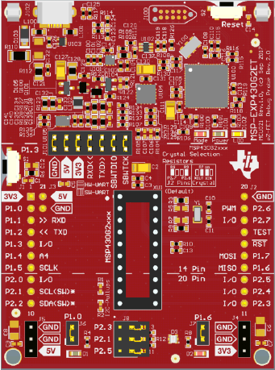

*Fig.1. MSP-EXP430G2ET LaunchPad Development Kit.*

**Q2.)**

|  |  |  |
| --- | --- | --- |
| **A** | **B** | **A XOR B** |
| 0 | 0 | 0 |
| 0 | 1 | 1 |
| 1 | 0 | 1 |
| 1 | 1 | 0 |

*Table 1. Truth Table for XOR Operation*

As can be seen from the table, when "XORing with 1" is performed, the 2's complement of the desired bits is obtained. In other words, if the input is high, the output is low, and if the input is low, the output is low.

|  |
| --- |
| **int** **main**(**void**){  **unsigned** **int** MyNumber = 0x00;  MyNumber ^= 0x01; // MyNumber = 00000000 XOR 00000001 = 00000001  MyNumber ^= 0x01; // MyNumber = 00000001 XOR 00000001 = 00000000  **return**(0);  } |

**Q3.)**

To understand the state of a Bit, we can "AND with 1" because if we "AND with 1 on a bit" the result will be whatever the number is.

|  |
| --- |
| MyNumber &= 1; // MyNumber = MyNumber AND 1 = MyNumber    // TO GET THE STATUS OF MULTIPLE BITS  MyNumber &= 0x03; // MyNumber = MyNumber AND 00000101  MyNumber &= (BIT0|BIT2); // MyNumber = MyNumber AND 00000101 |

**Q4.)**

Bouncing is the tendency of any two metal contacts in an electronic device to generate multiple signals as the contacts close or open; **debouncing** is any kind of hardware device or software that ensures that only a single signal will be acted upon for a single opening or closing of a contact.

In some applications, a return operation may be needed because a wavy signal may be harmful to our device, and it may also prevent us from getting the expected results even if the algorithm we have installed is correct.

|  |
| --- |
| **#include** <msp430.h>  **#define** Switch BIT3 // Switch -> P1.3  **#define** GreenLED BIT0 // Green LED -> P1.0  **void** **main**(**void**) {  WDTCTL = WDTPW | WDTHOLD; // Stop Watchdog Timer  P1DIR |= GreenLED; // Set LED pin -> Output  P1DIR &= ~Switch; // Set SW pin -> Input  P1REN |= Switch; // Enable Resistor for SW pin  P1OUT |= Switch; // Select Pull Up for SW pin  P1OUT &= Switch; // P1 is zero without P1.3 because of Pull Up Conf.  **while**(1){  **if**(!(P1IN&Switch)){ // If SW is Pressed  **while**(!(P1IN & Switch)); // Wait till Switch Released  P1OUT ^= GreenLED; // Toggle LED  }  }  } |

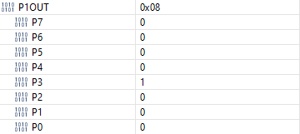 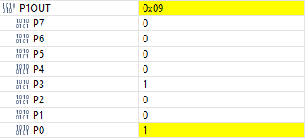

When the Green Led is OFF When the Green Led is ON

**Q5.)**

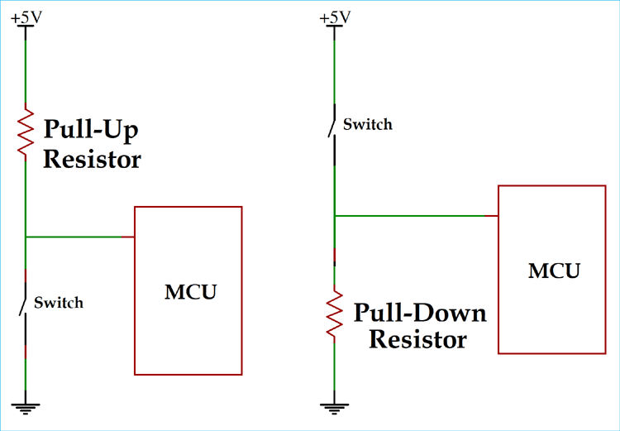

A microcontroller in any embedded system utilizes I/O signals to communicate with the external devices. The simplest form of I/O is usually stated to as GPIO(General Purpose Input/Output). When the GPIO voltage level is low, then it is in high or high impedance state, then the pull up and pull-down resistors are used to ensure GPIO which is always in a valid state.

Some microcontrollers, including the MSP430, have these pull-up, pull-down resistors built-in. Thus, the operation can be performed using the software without the need for any external components.

|  |
| --- |
| P1REN |= Switch; // Pull-Up/Pull-Down Resistors enabled for Button.  P1OUT |= Switch; // Button is enabled as Pull-Up. |

**Q6.)**

|  |
| --- |
| **int** **main**(**void**){  WDTCTL = WDTPW | WDTHOLD; // Stop Watchdog Timer  **volatile** **unsigned** **int** Aydugan;  **volatile** **unsigned** **int** Egemen_Can;  **volatile** **unsigned** **int** i;  Aydugan = 0;  Egemen_Can = 19; // ÇORUM (0001 0011)  **for**(i=0; i<4;i++){ // Final Egemen_Can = 0001 0011 0000 = 304  Egemen_Can = Egemen_Can << 1;  }  Aydugan = Egemen_Can & 0x30;  // 0001 0011 0000 And 0000 0011 0000 = 0011 0000 = 0x30  **return** 0 ;  } |



Initial Values



After Shifting Left 4 Times

Egemen_Can = (0001 0011)b << 4 = (0001 0011 0000)b = 0x130



Final Values

Aydugan = (0001 0011 0000)b AND (0000 0011 0000)b = (0011 0000)b = (0011 0000)b = 0x30

**Q7.)**

|  |
| --- |
| **int** **main**(**void**){  WDTCTL = WDTPW | WDTHOLD; // Stop watchdog timer  P1SEL = 0x0000; // P1 became GPIO.  P1DIR |= 0x0001; // P1.0 pin is output.  P1OUT= 0x0000; // Starts with P1.0 = 0.  **volatile** **unsigned** **int** i=0;  **while**(1){  **if**(i<2){  P1OUT = P1OUT ^ 0001; // 1sn ON, 1sn OFF  **__delay_cycles**(1000000); // Delay 1 second (Short Delay)  i++;  }  **if**(i>=2){  P1OUT = P1OUT ^ 0001; // 3sn ON, 3sn OFF  **__delay_cycles**(3000000); // Delay 3 second (Long Delay)  i++;  **if**(i==4){  i=0;  }  }  }  } |